

**EEG (Electroencephalography)**

**Signal Processing and Analysis**

**Module: Advanced Signal Processing**

**B00122875**

**Vimal Jaswal**

**TU Dublin - Blanchardstown Campus**

**Contents**

|  |  |
| --- | --- |
| 1. **Introduction** | Page 3 |
| 1. **Electroencephalography (EEG)** | Page 3 |
| 1. **EEG Signals and its Characterizations** | Page 4 |
| 1. **Measurement of brain activity by EEG** | Page 5 |
| 1. **Types of Artefacts in EEG Signals** | Page 6 |
| 1. **Artefact Elimination from EEG Signals** | Page 7 |
| 1. **Plotting EEG signal Data in MATLAB** | Page 7 |
| 1. **Filter Design and Analysis using MATLAB** | Page 9 |
| 1. **Feature Extraction of EEG Signal by digital filtering and Spectrogram** | Page 16 |
| 1. **EEG Advanced Feature Extraction Tools** | Page 17 |
| 1. **CONCLUSION** | Page 18 |
| 1. **REFERENCES** | Page 19 |
| 1. **APPENDIX** | Page 19 |

**Introduction**

The purpose of this report is to understand the concept of EEG signals and application of tools and techniques that can be used for its processing, filtering, classification and analysis. I have used MATLAB for designing digital filters for EEG and those filters have been applied to extract EEG waveform desired for detection of brain activities. Further I have done spectrogram analysis to compare various condition of the subject. The filters designed works efficiently. This report explains EEG signals and its features, artefacts or noise related to these signals, mitigation and artefacts removal techniques, filtering methods and EEG waveform extraction process.

**Electroencephalography (EEG)**

An EEG is a neurological test generally performed on humans to record the electrical potential or activities of brain. The intensity of EEG signal is quite small and measured in microvolts. An EEG device usually tracks, and records brain wave patterns and the signals records are saved on a computer system. Normal activities in the healthy brain makes a recognizable pattern that can be compared to diseased or abnormal patterns to recognise various types of diseases related to brain. EEG test helps in diagnosing many brain disorders such as tumors, seizures, Alzheimer’s disease, epilepsy, sleep disorders, insomnia and other disorders. The first ever EEG recording was obtained by German physiologist and psychiatrist Hans Berger in 1924.

Human brain consists of large number of neuron network which are interconnected to each other and that generates electrical impulse signals in the brain. Human brain approximately contains 100 billion of neurons. A neuron contains many dendrites, a cell body and a long axon which carries the electrical impulse. Neurons are of various types and each neuron has its own function depending upon its structure.

Cerebrum, Cerebellum and brain stem are three major parts of human brain. The largest portion of the brain is Cerebrum. Cerebrum controls activities like thinking, movements, problem solving and feeling. Cerebellum is responsible for balance and coordination. Brain stem is responsible for automatic operations like breathing, digestion, heart rate and blood pressure. There. The Frontal, Parietal, Occipital and Temporal lobe are four major lobes in the Brain.

The international 10-20 system is used for recording clinical EEGs. The anatomical reference points are defined on the top of the nose (nasion) and back of the skull (inion). The letters F,P,C,T,O and A represent the sections frontal, Parietal, Central, Temporal, Occipital and auricle. Electrodes are named accordingly and odd are placed on left side and even on right side and the middle line act as zero.[1]



Two methods for measuring the electrical activity of the brain is most common - invasive and non-invasive. Electrodes are physically implanted inside the human brain in case of invasive method. They also include surgical methods and are not usually recommended. Electrodes are placed on the surface of the skin to measure the electrical potential in case of non- invasive method. The non-invasive method is painless and safe. Both the methods allow us to monitor and visualize the brain by providing different observations and results.

**EEG Signals and its Characterizations / Brain Signal Patterns**

The Brain waves are categorized according to the position of electrodes on the scalp, shape, frequency and amplitude. The applications of EEG focus on a comparatively narrow band because most of the EEG signal power lies in frequency range from 0.1 Hz to 100 Hz.

EEG signals classification based on frequency range:

**Delta waves**(**𝛿**) are in the frequency range between 0.5 - 4 Hz. Delta waves are the slowest waves. Delta waves usually occur sometimes when awake, in a comma and deep sleep. More occurrence of delta waves in awake state is referred to as a dangerous condition.

**Theta waves(θ):**  Theta waves have frequency range between 3.5 - 7.5 Hz. Theta waves originate from temporal, central and parietal regions of brain. Abnormal adults generally have High level of theta waves production in brain. Theta waves occurs during stress, deep meditation and creative thinking state.

**Alpha waves(α) :** The frequency range of alpha waves is from 8 Hz - 12 Hz. These types of waves arise from backside of the head and occipital lobe. Alpha waves dominate in calm mental and relaxed states while being awake. They have higher amplitude than delta and theta waves.

**Beta waves(β):** Beta waves have frequency ranging from 13 - 30 Hz and these waves are associated to high concentration level, anxious state and deep thinking. As compared with other waves beta waves have larger frequency band. The central area of the brain and front side of head is responsible for originating Beta waves.

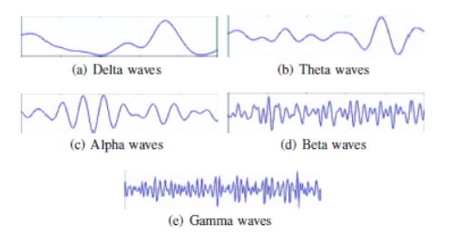

**Gamma waves(γ):** The frequency range of gamma waves lies in 30 Hz and greater. Multi-tasking, Motor functions, simultaneous work occur in this frequency range.[1]

**Measurement of brain activity by EEG**

It is done by various types of sensors in order to obtain signals accurately representing the subject’s brain activity.

**Pre-processing**: This process includes refining and artefact removal from input data in order to improve the information required from the EEG signals. The signal data is also amplified and filtered by digital filtering for better examination and post processing.

**Feature extraction:** Feature extraction is the process of describing the signals by relevant values and information compared to normal information.

**Classification:** The classification step assigns a class to a set of features extracted from eeg signals. This can also be called as feature translation. [1]

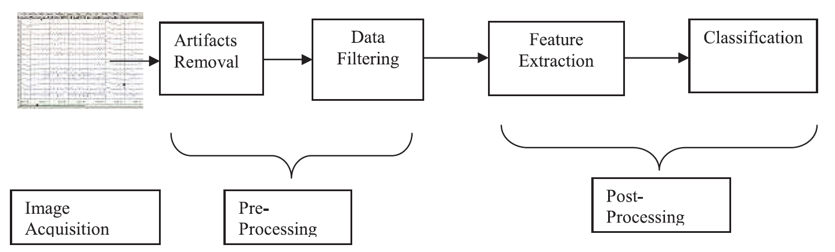

**Types of Artefacts in EEG Signals**

Depending upon the source of generation there are many different types of artefacts in a EEG recording of signals. If the source of noise is the subject’s body, the artefact is called physiological artefact. If the source is external it is called external artefact.

**Physiological Artefacts:** Physiological artefacts are the artefact originated because of electrical activity of other body parts of the subject under test.

1. **Artefacts related to the eyes and eyelids.** A movement of the eyes and eyeballs causes a change of impulse potential in the electrodes near the eyes at Frontal Parietal section i.e; Fp1-Fp2. Flickering of the eyes and eyelids generates as a 3Hz –10Hz signal.
2. **Eye movement artefacts.** Electroretinogram - ERG is a potential difference between cornea and retina of the eye. This potential changes with effect of incident light and resulting in artefacts in EEG signals.
3. **Eye blink.** Eye blinks produce high amplitude signals greater than the amplitude of EEG signals of interest. Repetitive blinks generate slow waves that seems as delta waves.
4. **Muscle Artefacts**: Muscle artefact are categorized into glossokenetic (swallow, grimacing, chewing, tongue movement) and can be observed in surface of electrode in EEG. The shape of artefact relies on the intensity of muscle contraction. This overlaps with beta band (13-30Hz) and appear less in sleep. Generally, it originates in the temporal and frontal electrode.
5. **Cardiac Artefacts:** The human heart generates two types of artefacts in EEG named mechanical and electrical artefacts which originate as ECG signal. ECG waveform forms the QRS complex and is recorded from scalp. Cardiac artefact has frequencies near to 1Hz. [2]

**Extra physiologic or External artefacts:** These are Technical artefacts, DC signal components, cable movements, electrodes, External, environmental sources of noise, AC power lines, lightening and array of electronic equipment from computers, displays and TVs to wireless routers, mobile phones.

**Transmission Line Artefact**: The interested bandwidth of an EEG signal is 0.5Hz-60Hz and the bandwidth of transmission lines is 50Hz or 60Hz. The transmission line artefact mixes with beta band of EEG signal. Transmission line artefact affects channels with poor impedance matching. This artefact can easily be separated and removed by using a notch filter of bandwidth 50 Hz or 60 Hz.

**Phone** **Artefact**: This artefact is due to mobile signals. To avoid this artefact, it is better not to keep mobile phone in the recording room.

**Electrode** **Artefact**: Skin contact of scalp with Poor electrode contact gives rise to low bandwidth artefacts as brief transients that are bound to one-electrode and synchronize with breathing due to the motion of the electrode. Electrode pop Artefact Appear as rapid transients that interrupt the background activity and generally confused with tumour. An electrode gel or paste is usually used in combination with electrodes to avoid these artefacts.

**Cable Movement:** Artefact Lead movement includes double phase reversal means phase reversals without the evenness in polarity that resembles a cerebrally produced electrical field.

**Physical movement Artefact** This artefact appears due to abrupt physical movement of subjects because of lose contact of electrodes.

**Artefact Elimination from EEG Signals**

Most of the artefacts can be avoided during recording of EEG by employing a good recording protocol, which involves providing instructions to the Patient or Subject regarding physical movement, eyes movement and avoiding mobile phones in EEG recording room. Experienced Physiologists recognizes artefact by visual analysis, digital filtering and remontaging. There are several ways of removing artefact such as manual and automation method. Automated removal methods use computer based mathematical algorithms which are used during digital EEG recording. On other hand the manual method is offline method which is applied after recording is saved.

**Filter method** Any particular artefact can be removed by using a band pass filter with a frequency range matching artefact. This method is not very effective for analysis of the entire frequency range of EEG because artefacts can occur at any bandwidth.

**Manual Method** Manual method is most reliable method of artefact removal. After recording, technical Physiologists visually inspects the EEG recording and eliminate the artefacts that are mixed with original EEG.

**Algorithm based removal**: Artefact Automatic artefact removal process employs mathematical algorithms like Independent component analysis, principle component analysis, EOG subtraction of matrices.[2]

**The standard filtering/Bandwidth settings for EEG:**

Low frequency filter: 1 Hz  
High frequency filter: 50-70 Hz

**Differential Amplifier:** Reduces the effect of common noise that can be present on the input electrodes. It magnifies the difference between two inputs. An unwanted signal that is common to the two inputs is subtracted. Power line noise is removed by a notch filter to reject the 60 Hz or 50 Hz. Band-pass or low-pass filters are the commonly used temporal filters which filter out a very high or low frequency bands leaving behind the particular frequency band in which we are interested. Filtering is commonly done by using Discrete Fourier Transform (DFT) or Finite Impulse Response (FIR) or Infinite Impulse Response (IIR) filters.

**Plotting EEG signal Data in MATLAB**

The recorded EEG signal is taken from Physiobank ATM in form of .mat file and is being used for digital filtering, feature extraction and analysis. The EEG data is plotted using Matlab software.

1. **EEG signal from first 5 channels recorded during “RSVP tasks edfm2a”**

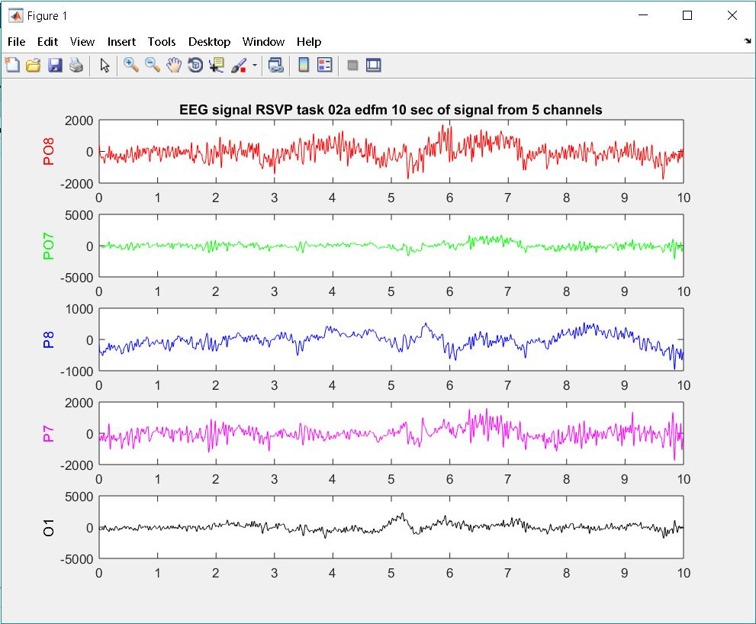

1. **EEG signal from first 5 channels “CAP sleep database sdb1”**

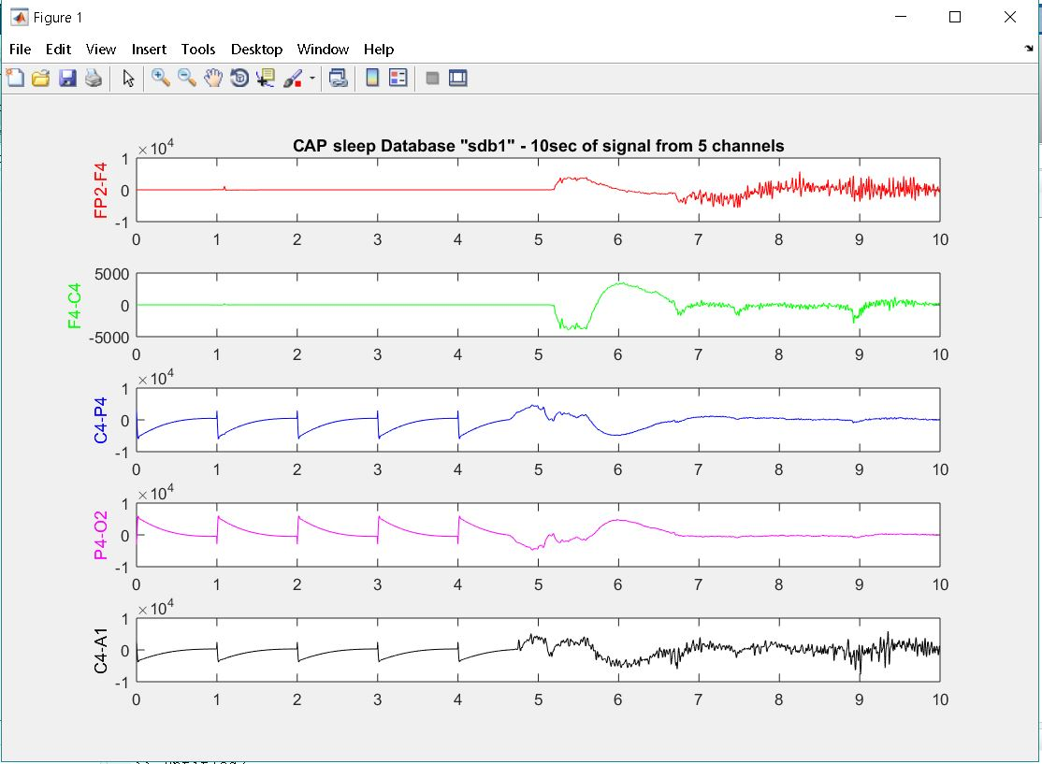

1. **EEG signal from first 5 channels “CAP sleep database brux1”**

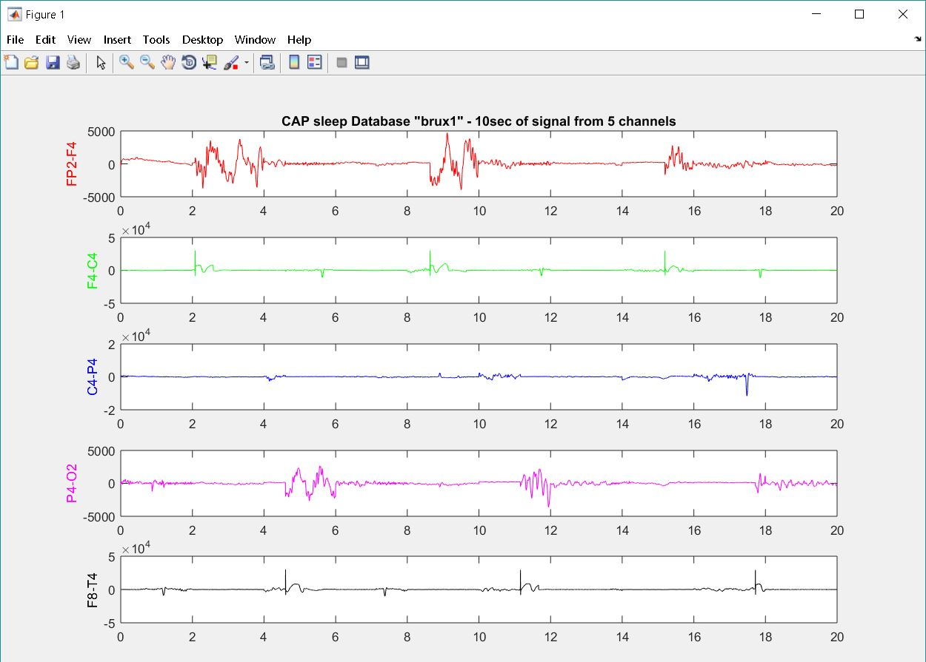

One channel EEG signal is considered from each of the above 5 channel signals and is used for applying digital filters and extraction of alpha, beta, delta, theta, gamma waves from these EEG signals for further analysis of signals.

**Filter Design and Analysis using MATLAB**

For applying filters in Matlab I have used filter design and analysis tool. In case of EEG signal we are interested in separating alpha, beta, delta, theta and gamma waves from the EEG signal. All these EEG waves have different frequency range. Therefore, I am using a band pass butterworth IIR filter for decomposition of signals as it will allow only specific frequency range of signal to pass through it and all other frequencies of signal will be blocked. Pass band IIR butterworth filter is used for extraction of all waves except the delta waves for which a low pass filter is being used as frequency of delta waves is from 0.5 to 4 Hz. The sampling frequency of the recorded signals is 2048 Hz for RSVP tasks database and 256 Hz for CAP sleep database, so the magnitude response of the filters would be different depending upon the sampling frequency.

**EEG recordings are taken from Physio bank Database for analysis in MATLAB tool:**

**The graphs generated by MATLAB are as in sequence below:**

1. Original EEG signal in time domain.
2. EEG signal Frequency domain by FFT – fast fourier transform
3. Alpha, Beta, Delta, Theta, Gamma waves separated from EEG signal by respective IIR Butterworth filters.
4. Spectrograms of the Extracted EEG rhythmic waves.

**Rapid Serial Visual Presentation (RSVP) ; PO8 channel; fs= 2048 Hz (Sampling frequency)**

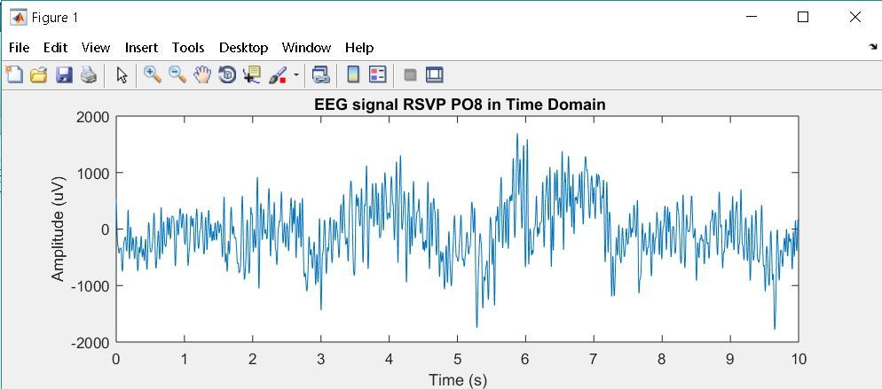

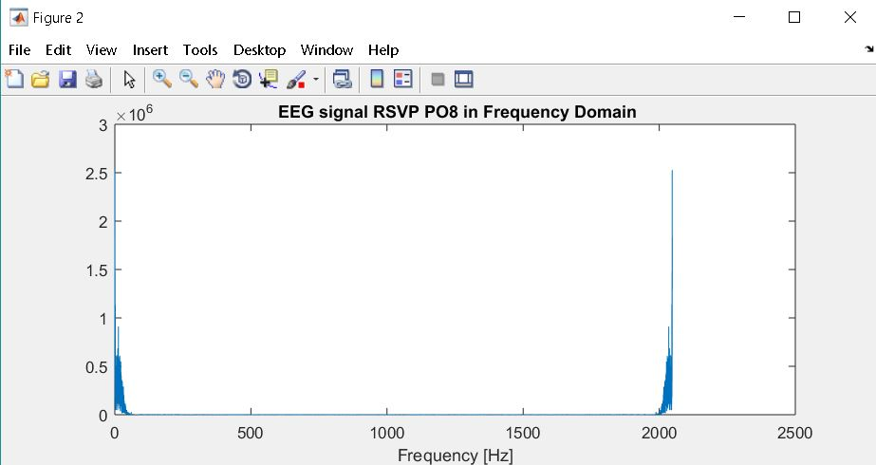

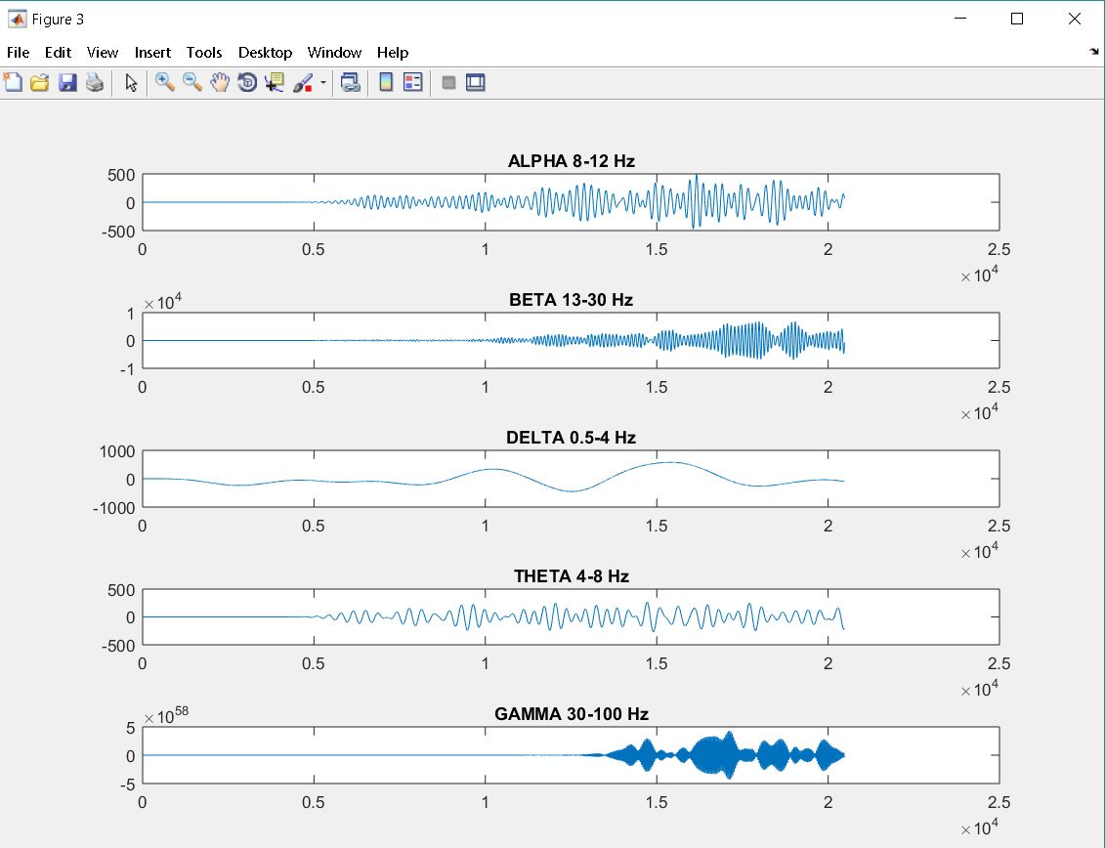

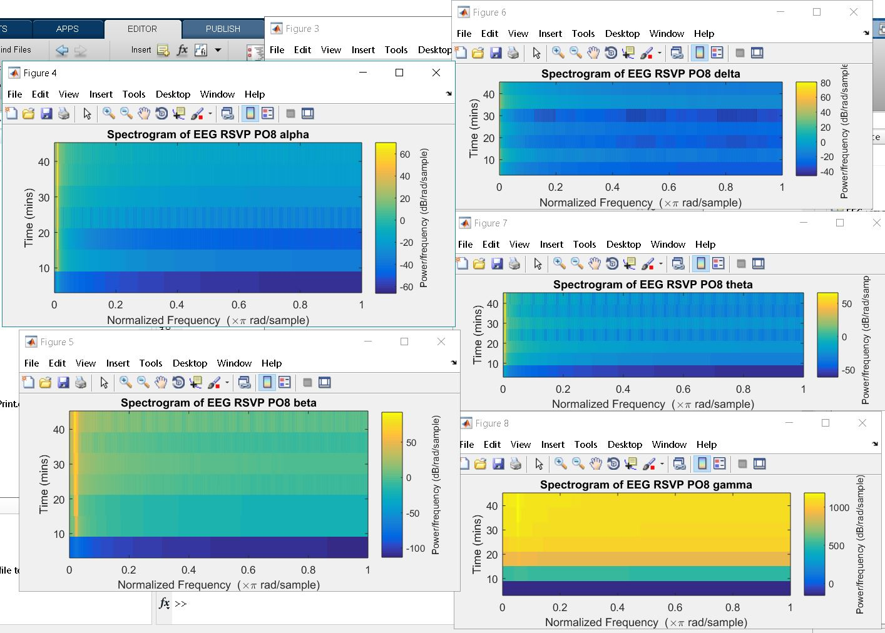

**The Cyclic Alternating Pattern (CAP) of EEG activity during sleep**

**Sleep-disordered breathing - sdb1 ; Channel C4-P4 ; Sampling frequency fs=256Hz**

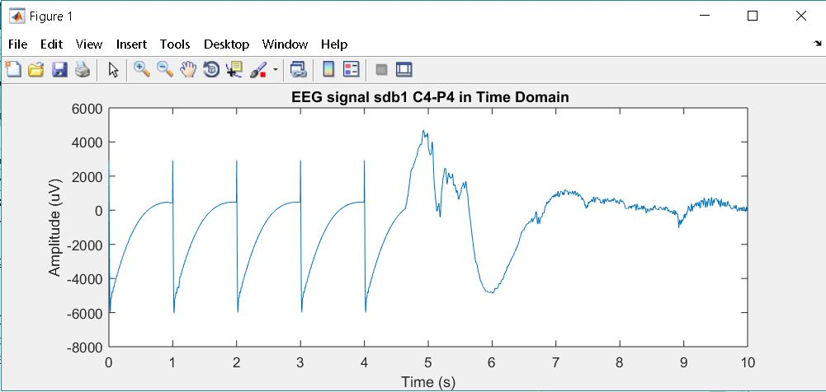

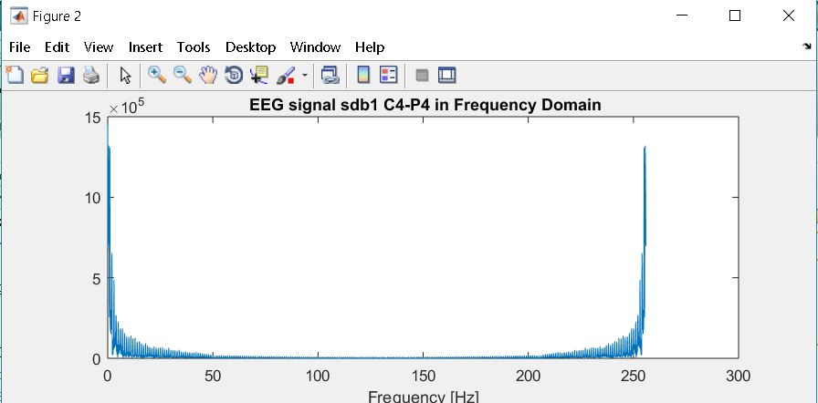

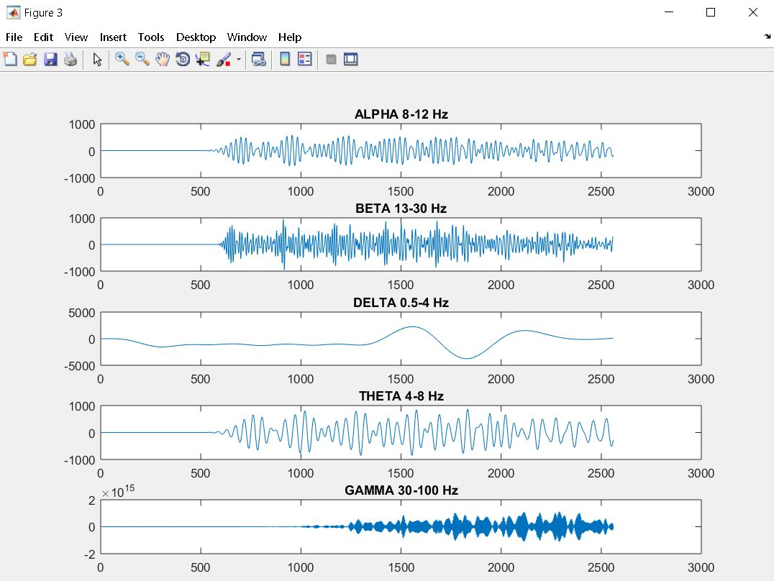

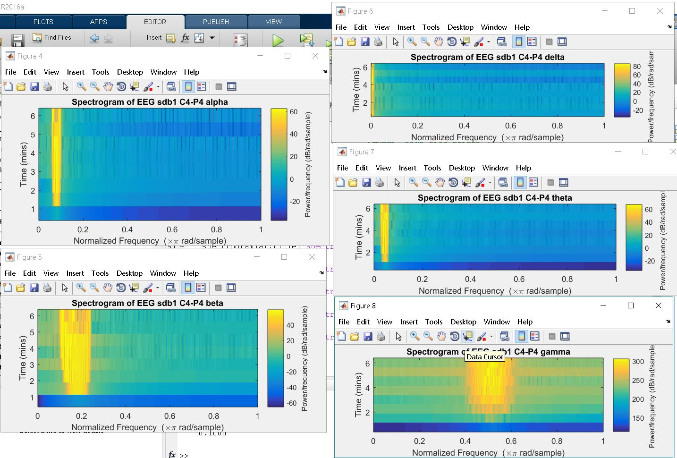

**Bruxism (condition in which person grind or clench your teeth) – brux1, fs=256 Hz , P4-O2**

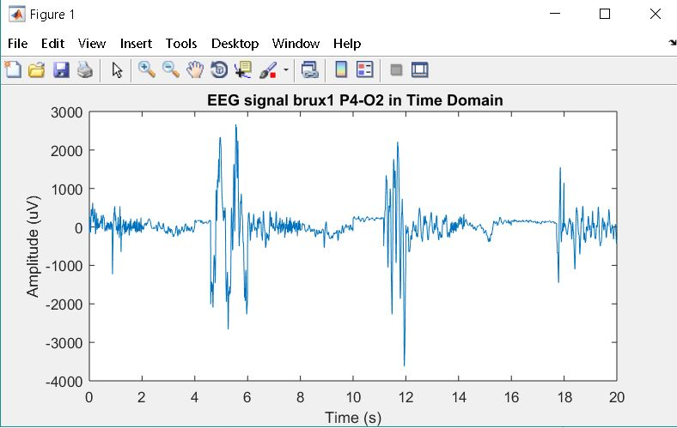

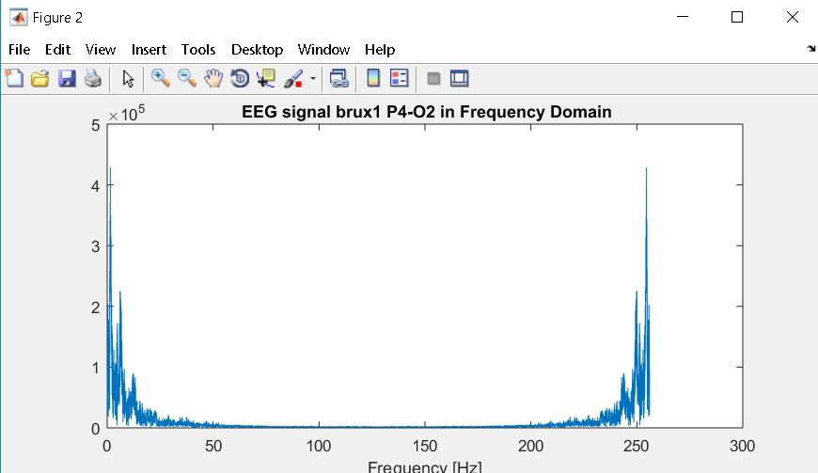

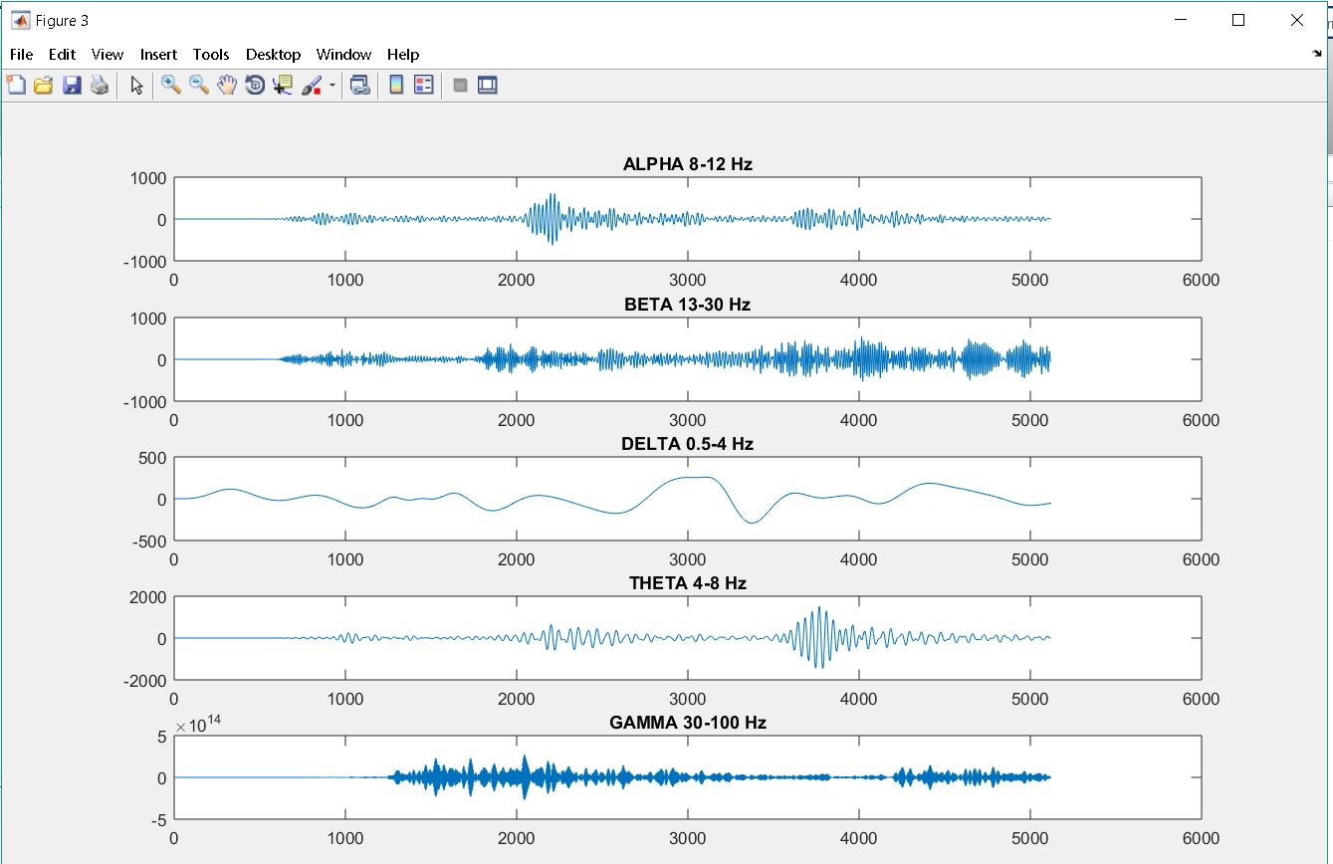

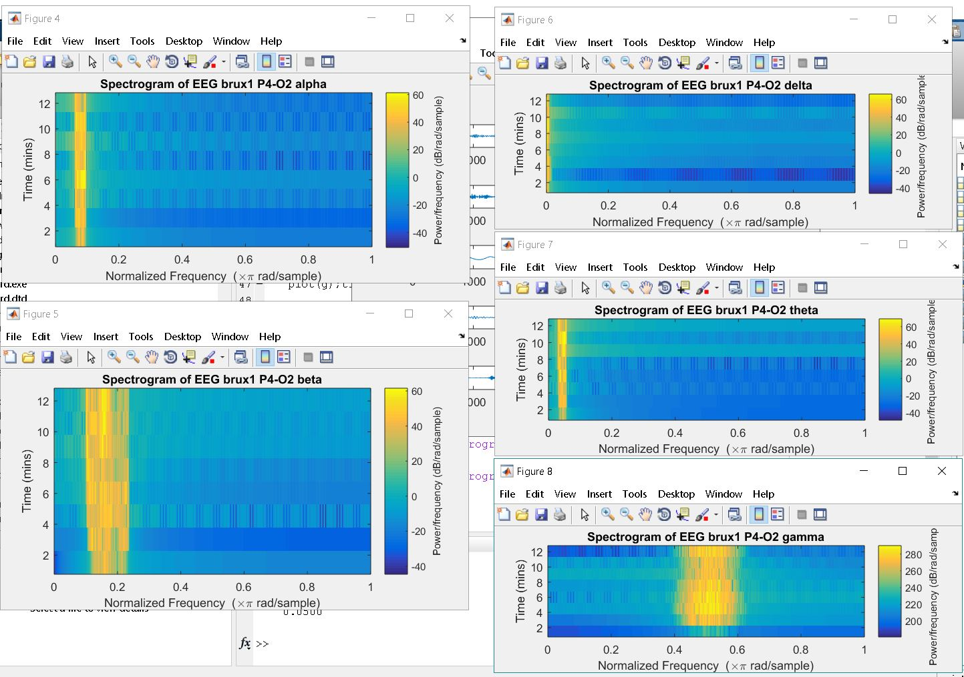

**Feature Extraction of EEG Signal by digital filtering and Spectrogram**

The corresponding waveforms are individually extracted by applying low-pass and band pass IIR (infinite impulse response) filters according to the frequency bands for each category of wave rhythm. The Magnitude or Frequency responses for each filter are shown in the Appendix with the signal gain variation with respect to frequency. Based on magnitude response, it is clear that the designed filters behave as required however, filters are not ideal. Therefore, a low pass filter of 4Hz is used to extract delta waves instead of a band pass filter.[3][4]

The alpha, beta, delta, theta and gamma waves extracted from each of the above shown channels are represented by two ways, plots of 10 seconds in time domain and figures showing spectrograms. The time domain figures show the change in amplitude of the signal in respective condition of the subject with respect to time and on the other hand, the spectrograms describe the variation in bandwidth of the signal with respect to time in form of colour bands. The spectrograms displayed for EEG channels clears that the filters are good and effective in separating out only the desired frequency bands and to represent waves feature. Digital filters are a reliable method of distinguishing EEG wave rhythms by frequency range. However, filtered signals are cleaner and less undesirable frequencies found as higher range of frequencies are filtered.

**EEG Advanced Feature Extraction Tools**

**WFDB Toolbox**

The WFDB Toolbox is open source tool available for MATLAB and Octave and it is a collection of functions for viewing, writing, and processing physiologic signals and time series in the formats used by Physio Bank databases. Around 50 Physio Bank databases containing signals ECG, EEG, EMG, ECG, PLETH (PPG), ABP, respiration and others can be accessed, analysed and processed using WFDB software tool along with MATLAB or OCTAVE. [3]

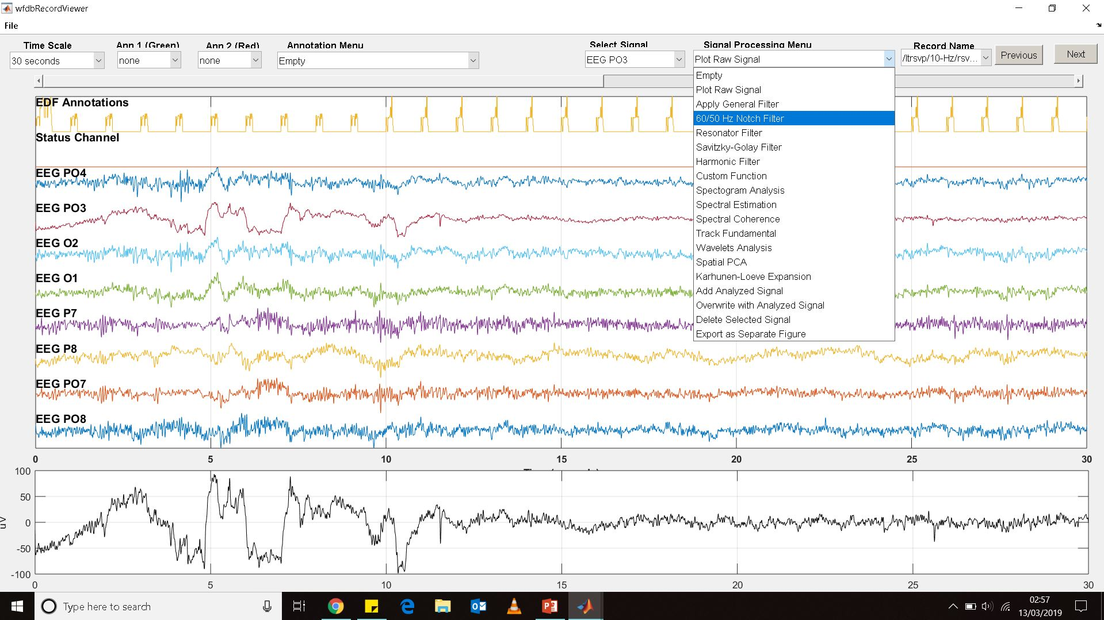

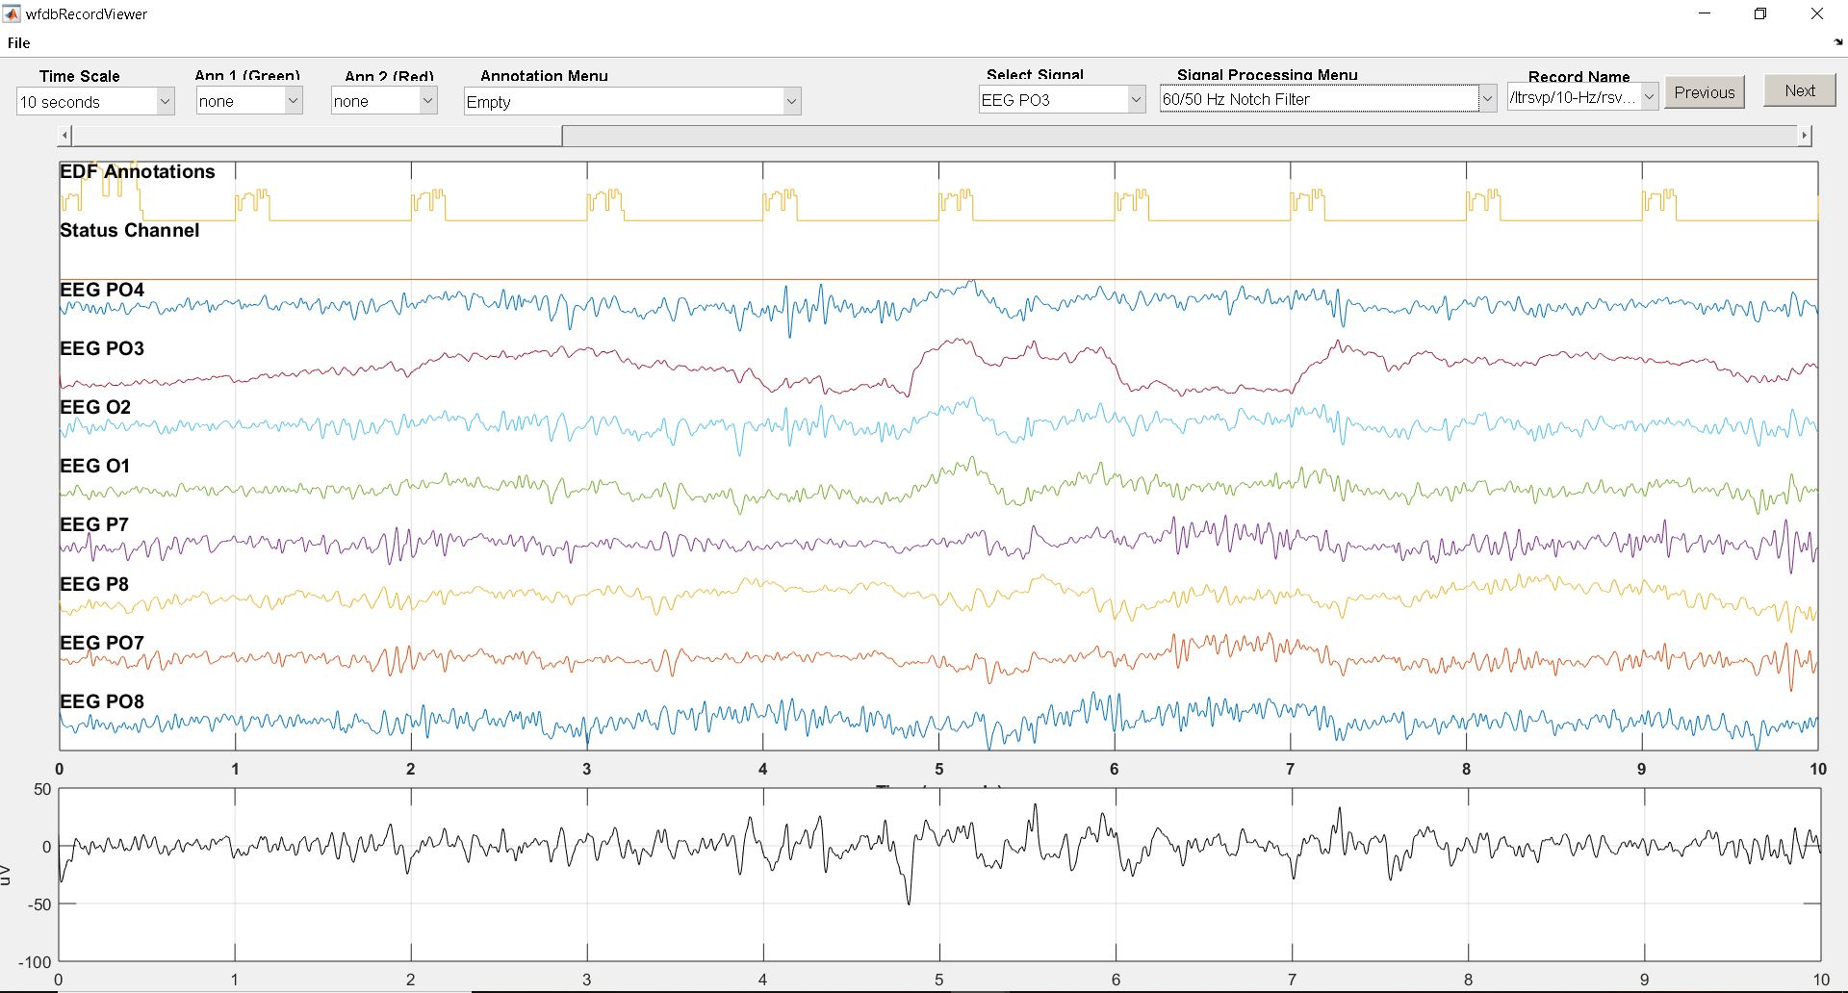

**EEGLAB toolbox for MATLAB**

EEGLAB is an interactive Matlab toolbox for processing continuous EEG, MEG and other electrophysiological signal data using independent component analysis, time-frequency analysis, artefact rejection, event-related statistics, and various useful modes of visualization. EEGLAB provides an interactive GUI that allow users to interactively process the EEG data and other dynamic brain data.[4]

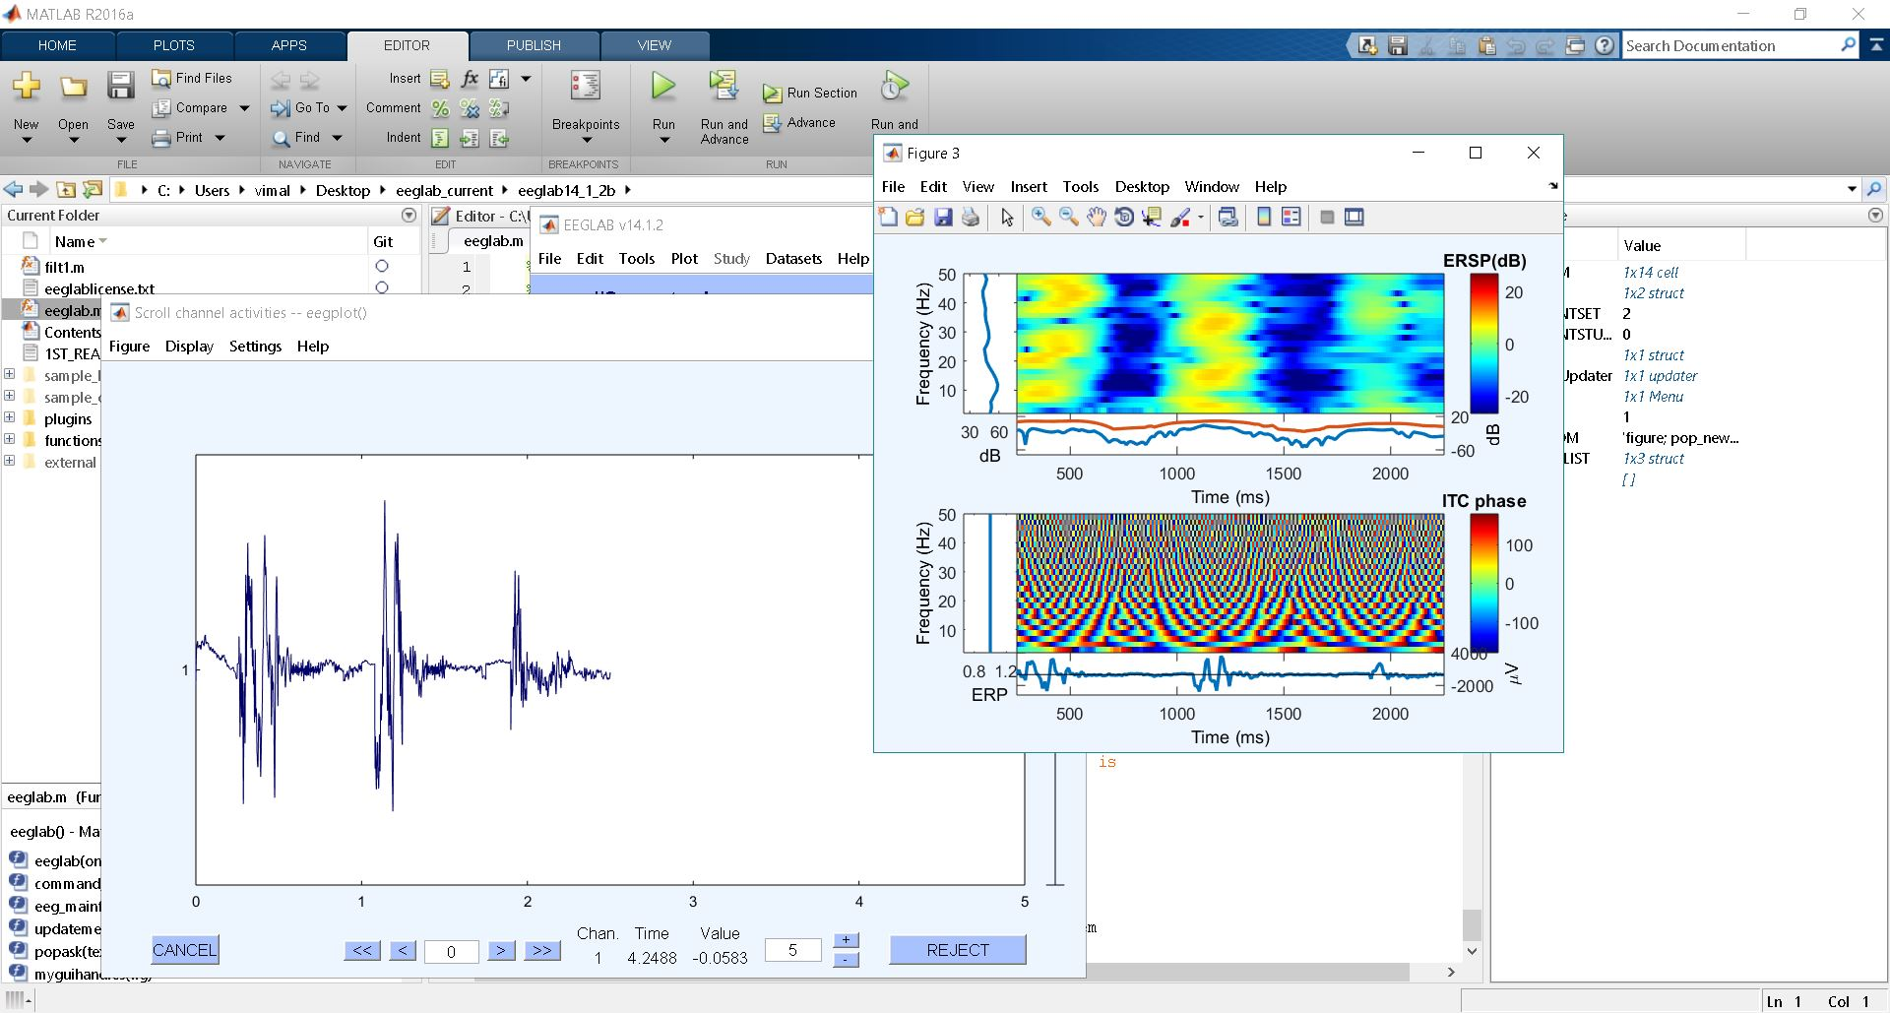

**Conclusion**

EEG waves can be separated into different wave patterns and each with different bandwidths and amplitude ranges. The primary EEG waveforms are alpha, beta, theta, delta and gamma waves. Digital filters and spectrogram method are a more direct approach for extracting EEG waveforms. although undesirable frequencies would still be expected to pass through because of non-ideal practical nature of the filters. Precisely, the filtered signals from digital filtering should not be considered to be identical to original results however it still fulfill the criteria for each wave of EEG signal. MATLAB is very useful and powerful computational software in digital signal processing. It is necessary for everyone whosoever is interested in the signal processing techniques to be familiar with the MATLAB environment. There are many other advanced software and alternatives available for signal processing such Octave and plugins for these like EEGLAB, WFDB tool with inbuilt algorithms and codes to apply filters and analysis of EEG signals. Proper analysis of EEG signal has application in biomedical application to cure several types of diseases related to human brain. The Study of EEG signal will remain the important aspect as brain is the most complex organ of human body and its analysis will unfold many mysteries and advanced application in future.

**References**

[1]J. Kumar and P. Bhuvaneswari, "Analysis of Electroencephalography (EEG) Signals and Its Categorization–A Study", *Procedia Engineering*, vol. 38, pp. 2525-2536, 2012. Available: 10.1016/j.proeng.2012.06.298.

[2]A. Tandle, N. Jog, P. D'cunha and M. Chheta, "Classification of Artefacts in EEG Signal Recordings and EOG Artefact Removal using EOG Subtraction", *Communications on Applied Electronics*, vol. 4, no. 1, pp. 12-19, 2016. Available: 10.5120/cae2016651997.

[3]"PhysioBank ATM", *Physionet.org*, 2019. [Online]. Available: https://physionet.org/cgi-bin/atm/ATM. [Accessed: 16- Mar- 2019].

[4]"MathWorks - Makers of MATLAB and Simulink", *Mathworks.com*, 2019. [Online]. Available: https://www.mathworks.com/. [Accessed: 16- Mar- 2019].

**APPENDIX**

**MATLAB CODE for multiple channels plot – RSVP TASK edfm 2a**

fs = 2048;

load ('C:\Users\vimal\Desktop\edfm\rsvp_10Hz_02a_edfm_PO8');

t =[0:length(val)-1]/fs;

PO8=val;

subplot (5,1,1);

plot(t,PO8, 'color', 'r'); ylabel('PO8', 'color', 'r');

title('EEG signal RSVP task 02a edfm 10 sec of signal from 5 channels');

load ('C:\Users\vimal\Desktop\edfm\rsvp_10Hz_02a_edfm_PO7');

t =[0:length(val)-1]/fs;

PO7=val;

subplot (5,1,2);

plot(t,PO7, 'color', 'g'); ylabel('PO7', 'color', 'g');

load ('C:\Users\vimal\Desktop\edfm\rsvp_10Hz_02a_edfm_P8');

t =[0:length(val)-1]/fs;

P8=val;

subplot (5,1,3);

plot(t,P8, 'color', 'b'); ylabel('P8', 'color', 'b');

load ('C:\Users\vimal\Desktop\edfm\rsvp_10Hz_02a_edfm_P7');

t =[0:length(val)-1]/fs;

P7=val;

subplot (5,1,4);

plot(t,P7, 'color', 'm'); ylabel('P7', 'color', 'm');

load ('C:\Users\vimal\Desktop\edfm\rsvp_10Hz_02a_edfm_O1');

t =[0:length(val)-1]/fs;

O1=val;

subplot (5,1,5);

plot(t,O1, 'color', 'k'); ylabel('O1', 'color', 'k');

**MATLAB CODE for multiple channels plot – CAP Sleep database sdb1**

fs = 256;% sampling frequency

load ('C:\Users\vimal\Desktop\edfm\sdb1_edfm_FP2-FP4');

t =[0:length(val)-1]/fs;

FP2_FP4=val;

subplot (5,1,1);

plot(t,FP2_FP4, 'color', 'r'); ylabel('FP2-F4', 'color', 'r');

title('CAP sleep Database "sdb1" - 10sec of signal from 5 channels');

load ('C:\Users\vimal\Desktop\edfm\sdb1_edfm_F4-C4');

t =[0:length(val)-1]/fs;

F4_C4=val;

subplot (5,1,2);

plot(t,F4_C4, 'color', 'g'); ylabel('F4-C4', 'color', 'g');

load ('C:\Users\vimal\Desktop\edfm\sdb1_edfm_C4-P4');

t =[0:length(val)-1]/fs;

C4_P4=val;

subplot (5,1,3);

plot(t,C4_P4, 'color', 'b'); ylabel('C4-P4', 'color', 'b');

load ('C:\Users\vimal\Desktop\edfm\sdb1_edfm_P4-O2');

t =[0:length(val)-1]/fs;

P4_O2=val;

subplot (5,1,4);

plot(t,P4_O2, 'color', 'm'); ylabel('P4-O2', 'color', 'm');

load ('C:\Users\vimal\Desktop\edfm\sdb1_edfm_C4-A1');

t =[0:length(val)-1]/fs;

C4_A1=val;

subplot (5,1,5);

plot(t,C4_A1, 'color', 'k'); ylabel('C4-A1', 'color', 'k');

**MATLAB CODE for multiple channels plot – CAP Sleep database brux1**

fs = 256;% sampling frequency

load ('C:\Users\vimal\Desktop\edfm\brux1_edfm_fp2-fp4');

t =[0:length(val)-1]/fs;

FP2_FP4=val;

subplot (5,1,1);

plot(t,FP2_FP4, 'color', 'r'); ylabel('FP2-F4', 'color', 'r');

title('CAP sleep Database "brux1" - 10sec of signal from 5 channels');

load ('C:\Users\vimal\Desktop\edfm\brux1_edfm_f4-c4');

t =[0:length(val)-1]/fs;

F4_C4=val;

subplot (5,1,2);

plot(t,F4_C4, 'color', 'g'); ylabel('F4-C4', 'color', 'g');

load ('C:\Users\vimal\Desktop\edfm\brux1_edfm_c4-p4');

t =[0:length(val)-1]/fs;

C4_P4=val;

subplot (5,1,3);

plot(t,C4_P4, 'color', 'b'); ylabel('C4-P4', 'color', 'b');

load ('C:\Users\vimal\Desktop\edfm\brux1_edfm_p4-o2');

t =[0:length(val)-1]/fs;

P4_O2=val;

subplot (5,1,4);

plot(t,P4_O2, 'color', 'm'); ylabel('P4-O2', 'color', 'm');

load ('C:\Users\vimal\Desktop\edfm\brux1_edfm_f8-t4');

t =[0:length(val)-1]/fs;

F8_T4=val;

subplot (5,1,5);

plot(t,F8_T4, 'color', 'k'); ylabel('F8-T4', 'color', 'k');

**MATLAB CODE for RSVP task electrode PO8**

close all; clear all; clc; % Data taken from Physiobank RSVP tasks EEG

fs = 2048;% sampling frequency

load ('C:\Users\vimal\Desktop\edfm\rsvp_10Hz_02a_edfm_PO8');

t =[0:length(val)-1]/fs;

figure

plot(t,val);

xlabel('Time (s)'), ylabel('Amplitude (uV)'),

title(' EEG signal RSVP PO8 in Time Domain'); %EEG signal in time domain

%EEG signal in frequency domain by FFT

x_fft=fft(val);

step = fs/(length(x_fft)-1)

freq = 0:step:fs;

figure

plot(freq, abs(x_fft))

xlabel('Frequency [Hz]'), title(' EEG signal RSVP PO8 in Frequency Domain');

EEG_vimal=val;

figure;

Hd = alpha;

a= filter(Hd,EEG_vimal);

subplot (5,1,1);

plot(a);title('ALPHA 8-12 Hz'); %ALPHA BAND PASS FILTER (8-12)

Hd = beta;

b= filter(Hd,EEG_vimal);

subplot (5,1,2);

plot(b);title('BETA 13-30 Hz'); %BETA BAND PASS FILTER (13-30)

Hd = delta;

d= filter(Hd,EEG_vimal);

subplot (5,1,3);

plot(d);title('DELTA 0.5-4 Hz'); %Delta LOW PASS filter (0.5-4)

Hd = theta;

t= filter(Hd,EEG_vimal);

subplot (5,1,4);

plot(t);title('THETA 4-8 Hz'); %THETA BAND PASS FILTER (4-8)

Hd = gamma;

g= filter(Hd,EEG_vimal);

subplot (5,1,5);

plot(g);title('GAMMA 30-100 Hz'); % GAMMA BAND PASS FILTER (30-100)

figure

spectrogram(a);title('Spectrogram of EEG RSVP PO8 alpha')

figure

spectrogram(b);title('Spectrogram of EEG RSVP PO8 beta')

figure

spectrogram(d);title('Spectrogram of EEG RSVP PO8 delta')

figure

spectrogram(t);title('Spectrogram of EEG RSVP PO8 theta')

figure

spectrogram(g);title('Spectrogram of EEG RSVP PO8 gamma')

**FILTER functions and magnitude response for RSVP task electrode PO8**

function Hd = alpha

%ALPHA Returns a discrete-time filter object.

% MATLAB Code

% Generated by MATLAB(R) 9.0 and the Signal Processing Toolbox 7.2.

% Generated on: 12-Mar-2019 20:15:19

% Butterworth Bandpass filter designed using FDESIGN.BANDPASS.

% All frequency values are in Hz.

Fs = 2048; % Sampling Frequency

Fstop1 = 7.5; % First Stopband Frequency

Fpass1 = 8; % First Passband Frequency

Fpass2 = 12; % Second Passband Frequency

Fstop2 = 12.5; % Second Stopband Frequency

Astop1 = 60; % First Stopband Attenuation (dB)

Apass = 1; % Passband Ripple (dB)

Astop2 = 80; % Second Stopband Attenuation (dB)

match = 'passband'; % Band to match exactly

% Construct an FDESIGN object and call its BUTTER method.

h = fdesign.bandpass(Fstop1, Fpass1, Fpass2, Fstop2, Astop1, Apass, ...

Astop2, Fs);

Hd = design(h, 'butter', 'MatchExactly', match);

% [EOF]

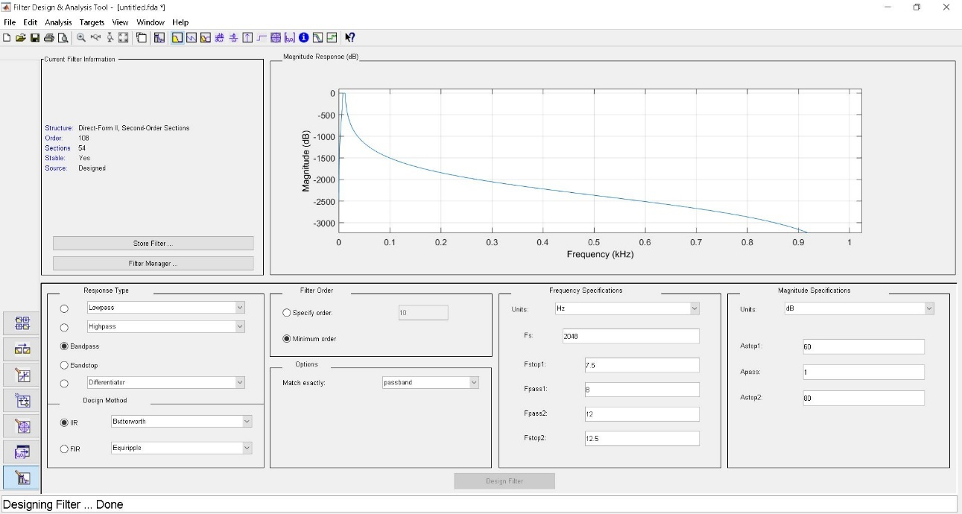

function Hd = beta

%BETA Returns a discrete-time filter object.

% MATLAB Code

% Generated by MATLAB(R) 9.0 and the Signal Processing Toolbox 7.2.

% Generated on: 12-Mar-2019 20:19:31

% Butterworth Bandpass filter designed using FDESIGN.BANDPASS.

% All frequency values are in Hz.

Fs = 2048; % Sampling Frequency

Fstop1 = 12.5; % First Stopband Frequency

Fpass1 = 13; % First Passband Frequency

Fpass2 = 30; % Second Passband Frequency

Fstop2 = 30.5; % Second Stopband Frequency

Astop1 = 60; % First Stopband Attenuation (dB)

Apass = 1; % Passband Ripple (dB)

Astop2 = 80; % Second Stopband Attenuation (dB)

match = 'passband'; % Band to match exactly

% Construct an FDESIGN object and call its BUTTER method.

h = fdesign.bandpass(Fstop1, Fpass1, Fpass2, Fstop2, Astop1, Apass, ...

Astop2, Fs);

Hd = design(h, 'butter', 'MatchExactly', match);

% [EOF]

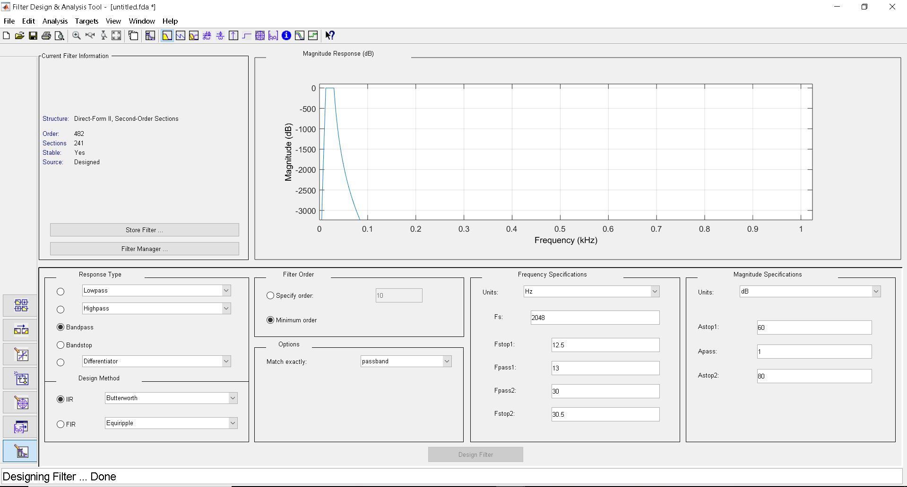

function Hd = delta

%DELTA Returns a discrete-time filter object.

% MATLAB Code

% Generated by MATLAB(R) 9.0 and the Signal Processing Toolbox 7.2.

% Generated on: 12-Mar-2019 20:24:09

% Butterworth Lowpass filter designed using FDESIGN.LOWPASS.

% All frequency values are in Hz.

Fs = 2048; % Sampling Frequency

Fpass = 0.5; % Passband Frequency

Fstop = 4; % Stopband Frequency

Apass = 1; % Passband Ripple (dB)

Astop = 80; % Stopband Attenuation (dB)

match = 'passband'; % Band to match exactly

% Construct an FDESIGN object and call its BUTTER method.

h = fdesign.lowpass(Fpass, Fstop, Apass, Astop, Fs);

Hd = design(h, 'butter', 'MatchExactly', match);

% [EOF]

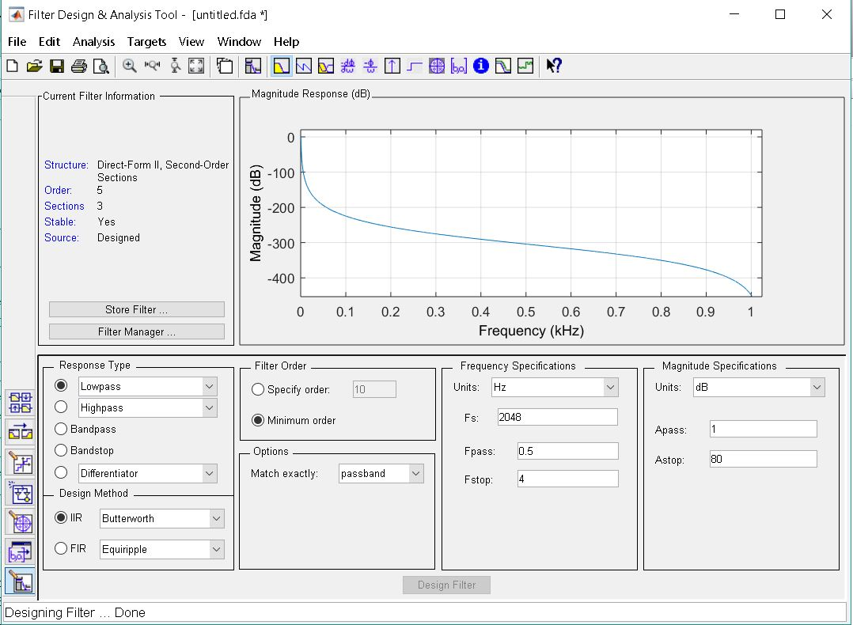

function Hd = theta

%THETA Returns a discrete-time filter object.

% MATLAB Code

% Generated by MATLAB(R) 9.0 and the Signal Processing Toolbox 7.2.

% Generated on: 12-Mar-2019 20:26:05

% Butterworth Bandpass filter designed using FDESIGN.BANDPASS.

% All frequency values are in Hz.

Fs = 2048; % Sampling Frequency

Fstop1 = 3.5; % First Stopband Frequency

Fpass1 = 4; % First Passband Frequency

Fpass2 = 7; % Second Passband Frequency

Fstop2 = 7.5; % Second Stopband Frequency

Astop1 = 60; % First Stopband Attenuation (dB)

Apass = 1; % Passband Ripple (dB)

Astop2 = 80; % Second Stopband Attenuation (dB)

match = 'passband'; % Band to match exactly

% Construct an FDESIGN object and call its BUTTER method.

h = fdesign.bandpass(Fstop1, Fpass1, Fpass2, Fstop2, Astop1, Apass, ...

Astop2, Fs);

Hd = design(h, 'butter', 'MatchExactly', match);

% [EOF]

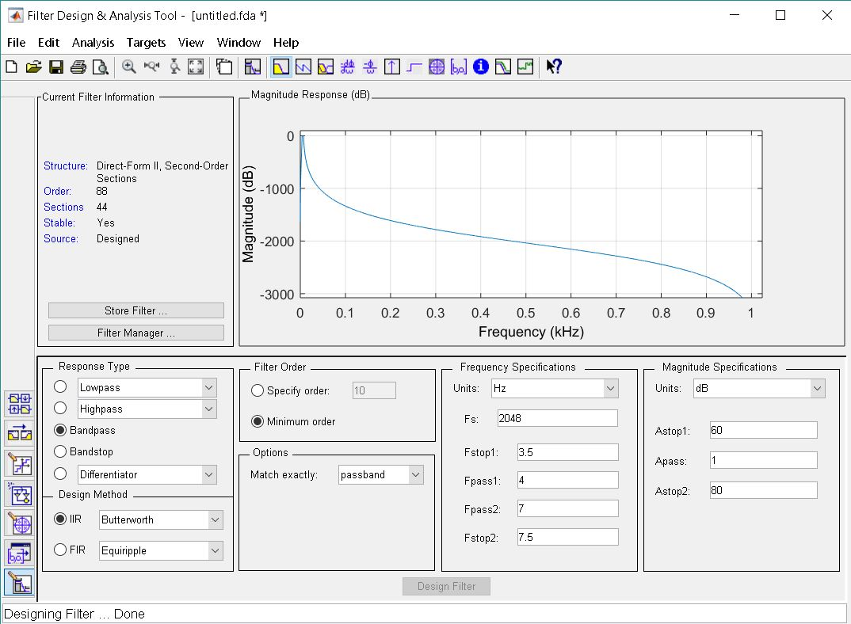

function Hd = gamma

%GAMMA Returns a discrete-time filter object.

% MATLAB Code

% Generated by MATLAB(R) 9.0 and the Signal Processing Toolbox 7.2.

% Generated on: 16-Mar-2019 15:07:47

% Butterworth Bandpass filter designed using FDESIGN.BANDPASS.

% All frequency values are in Hz.

Fs = 2048; % Sampling Frequency

Fstop1 = 29.5; % First Stopband Frequency

Fpass1 = 30; % First Passband Frequency

Fpass2 = 99.5; % Second Passband Frequency

Fstop2 = 100; % Second Stopband Frequency

Astop1 = 60; % First Stopband Attenuation (dB)

Apass = 1; % Passband Ripple (dB)

Astop2 = 80; % Second Stopband Attenuation (dB)

match = 'passband'; % Band to match exactly

% Construct an FDESIGN object and call its BUTTER method.

h = fdesign.bandpass(Fstop1, Fpass1, Fpass2, Fstop2, Astop1, Apass, ...

Astop2, Fs);

Hd = design(h, 'butter', 'MatchExactly', match);

% [EOF]

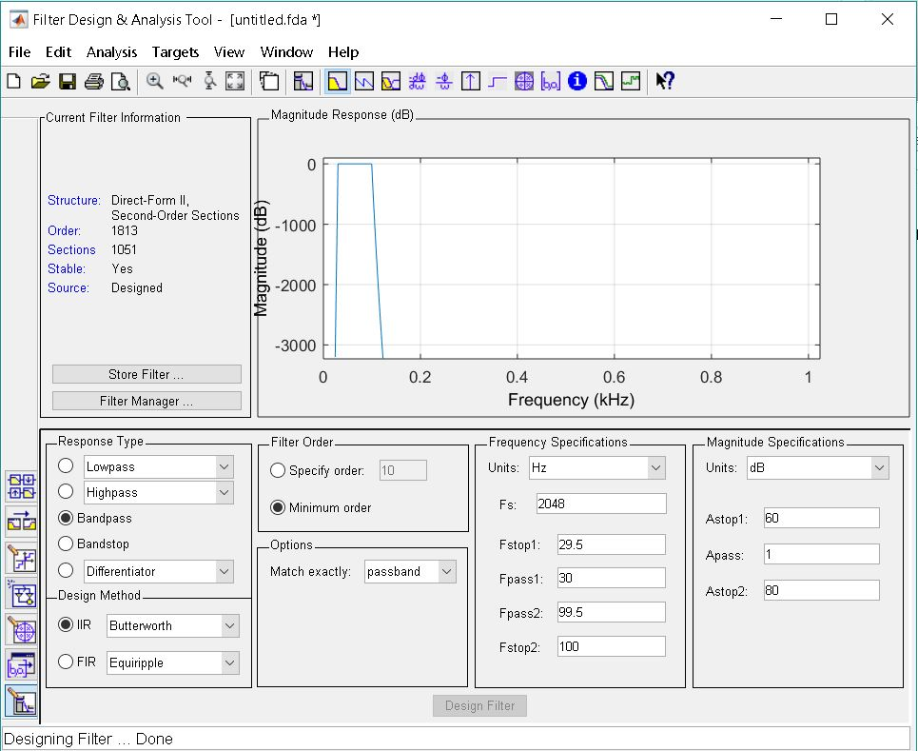

**MATLAB CODE CAP Sleep Database sdb1 electrode channel C4-P4**

close all; clear all; clc;

% Data taken from Physiobank CAP sleep database

load ('C:\Users\vimal\Desktop\edfm\sdb1_edfm_C4-P4');

fs = 256; % sampling frequency

t =[0:length(val)-1]/fs;

figure

plot(t,val);

xlabel('Time (s)'), ylabel('Amplitude (uV)'),

title(' EEG signal sdb1 C4-P4 in Time Domain'); %EEG signal in time domain

%get fft to represent eeg signal in frequency domain

x_fft=fft(val);

step = fs/(length(x_fft)-1)

freq = 0:step:fs;

figure

plot(freq, abs(x_fft))

xlabel('Frequency [Hz]'), title(' EEG signal sdb1 C4-P4 in Frequency Domain');

EEG=val;

figure;

Hd = alpha1;

a= filter(Hd,EEG);

subplot (5,1,1);

plot(a);title('ALPHA 8-12 Hz'); %ALPHA BAND PASS FILTER (8-12)

Hd = beta1;

b= filter(Hd,EEG);

subplot (5,1,2);

plot(b);title('BETA 13-30 Hz'); %BETA BAND PASS FILTER (13-30)

Hd = delta1;

d= filter(Hd,EEG);

subplot (5,1,3);

plot(d);title('DELTA 0.5-4 Hz'); %Delta LOW PASS filter (0.5-4)

Hd = theta1;

t= filter(Hd,EEG);

subplot (5,1,4);

plot(t);title('THETA 4-8 Hz'); %THETA BAND PASS FILTER (4-8)

Hd = gamma1;

g= filter(Hd,EEG);

subplot (5,1,5);

plot(g);title('GAMMA 30-100 Hz'); %GAMMA BAND PASS FILTER (4-8)

figure

spectrogram(a);title('Spectrogram of EEG sdb1 C4-P4 alpha')

figure

spectrogram(b);title('Spectrogram of EEG sdb1 C4-P4 beta')

figure

spectrogram(d);title('Spectrogram of EEG sdb1 C4-P4 delta')

figure

spectrogram(t);title('Spectrogram of EEG sdb1 C4-P4 theta')

figure

spectrogram(g);title('Spectrogram of EEG sdb1 C4-P4 gamma')

**MATLAB CODE CAP Sleep Database brux1 electrode channel P4-O2**

close all; clear all; clc;

% Data taken from Physiobank CAP sleep database

load ('C:\Users\vimal\Desktop\edfm\brux1_edfm_p4-o2');

fs = 256; % sampling frequency

t =[0:length(val)-1]/fs;

figure

plot(t,val);

xlabel('Time (s)'), ylabel('Amplitude (uV)'),

title(' EEG signal brux1 p4-o2 in Time Domain'); %EEG signal in time domain

%get fft to represent eeg signal in frequency domain

x_fft=fft(val);

step = fs/(length(x_fft)-1)

freq = 0:step:fs;

figure

plot(freq, abs(x_fft))

xlabel('Frequency [Hz]'), title(' EEG signal brux1 p4-o2 in Frequency Domain');

EEG=val;

figure;

Hd = alpha1;

a= filter(Hd,EEG);

subplot (5,1,1);

plot(a);title('ALPHA 8-12 Hz'); %ALPHA BAND PASS FILTER (8-12)

Hd = beta1;

b= filter(Hd,EEG);

subplot (5,1,2);

plot(b);title('BETA 13-30 Hz'); %BETA BAND PASS FILTER (13-30)

Hd = delta1;

d= filter(Hd,EEG);

subplot (5,1,3);

plot(d);title('DELTA 0.5-4 Hz'); %Delta LOW PASS filter (0.5-4)

Hd = theta1;

t= filter(Hd,EEG);

subplot (5,1,4);

plot(t);title('THETA 4-8 Hz'); %THETA BAND PASS FILTER (4-8)

Hd = gamma1;

g= filter(Hd,EEG);

subplot (5,1,5);

plot(g);title('GAMMA 30-100 Hz'); %GAMMA BAND PASS FILTER (4-8)

figure

spectrogram(a);title('Spectrogram of EEG brux1 p4-o2 alpha')

figure

spectrogram(b);title('Spectrogram of EEG brux1 p4-o2 beta')

figure

spectrogram(d);title('Spectrogram of EEG brux1 p4-o2 delta')

figure

spectrogram(t);title('Spectrogram of EEG brux1 p4-o2 theta')

figure

spectrogram(g);title('Spectrogram of EEG brux1 p4-o2 gamma')

**Filter Functions and Magnitude Responses**

function Hd = alpha

%ALPHA Returns a discrete-time filter object.

% MATLAB Code

% Generated by MATLAB(R) 9.0 and the Signal Processing Toolbox 7.2.

% Generated on: 12-Mar-2019 20:15:19

% Butterworth Bandpass filter designed using FDESIGN.BANDPASS.

% All frequency values are in Hz.

Fs = 256; % Sampling Frequency

Fstop1 = 7.5; % First Stopband Frequency

Fpass1 = 8; % First Passband Frequency

Fpass2 = 12; % Second Passband Frequency

Fstop2 = 12.5; % Second Stopband Frequency

Astop1 = 60; % First Stopband Attenuation (dB)

Apass = 1; % Passband Ripple (dB)

Astop2 = 80; % Second Stopband Attenuation (dB)

match = 'passband'; % Band to match exactly

% Construct an FDESIGN object and call its BUTTER method.

h = fdesign.bandpass(Fstop1, Fpass1, Fpass2, Fstop2, Astop1, Apass, ...

Astop2, Fs);

Hd = design(h, 'butter', 'MatchExactly', match);

% [EOF]

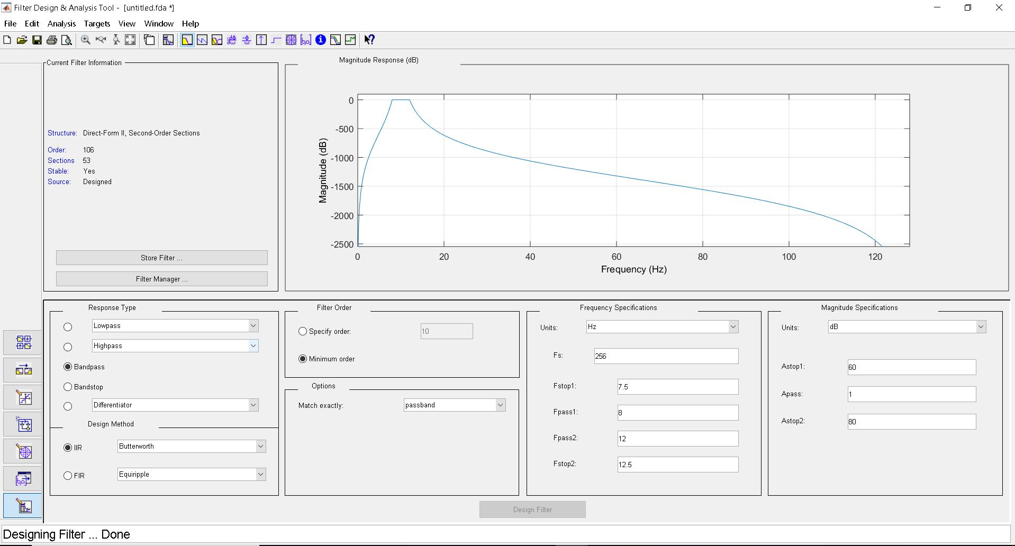

function Hd = beta

%BETA Returns a discrete-time filter object.

% MATLAB Code

% Generated by MATLAB(R) 9.0 and the Signal Processing Toolbox 7.2.

% Generated on: 12-Mar-2019 20:19:31

% Butterworth Bandpass filter designed using FDESIGN.BANDPASS.

% All frequency values are in Hz.

Fs = 256; % Sampling Frequency

Fstop1 = 12.5; % First Stopband Frequency

Fpass1 = 13; % First Passband Frequency

Fpass2 = 30; % Second Passband Frequency

Fstop2 = 30.5; % Second Stopband Frequency

Astop1 = 60; % First Stopband Attenuation (dB)

Apass = 1; % Passband Ripple (dB)

Astop2 = 80; % Second Stopband Attenuation (dB)

match = 'passband'; % Band to match exactly

% Construct an FDESIGN object and call its BUTTER method.

h = fdesign.bandpass(Fstop1, Fpass1, Fpass2, Fstop2, Astop1, Apass, ...

Astop2, Fs);

Hd = design(h, 'butter', 'MatchExactly', match);

% [EOF]

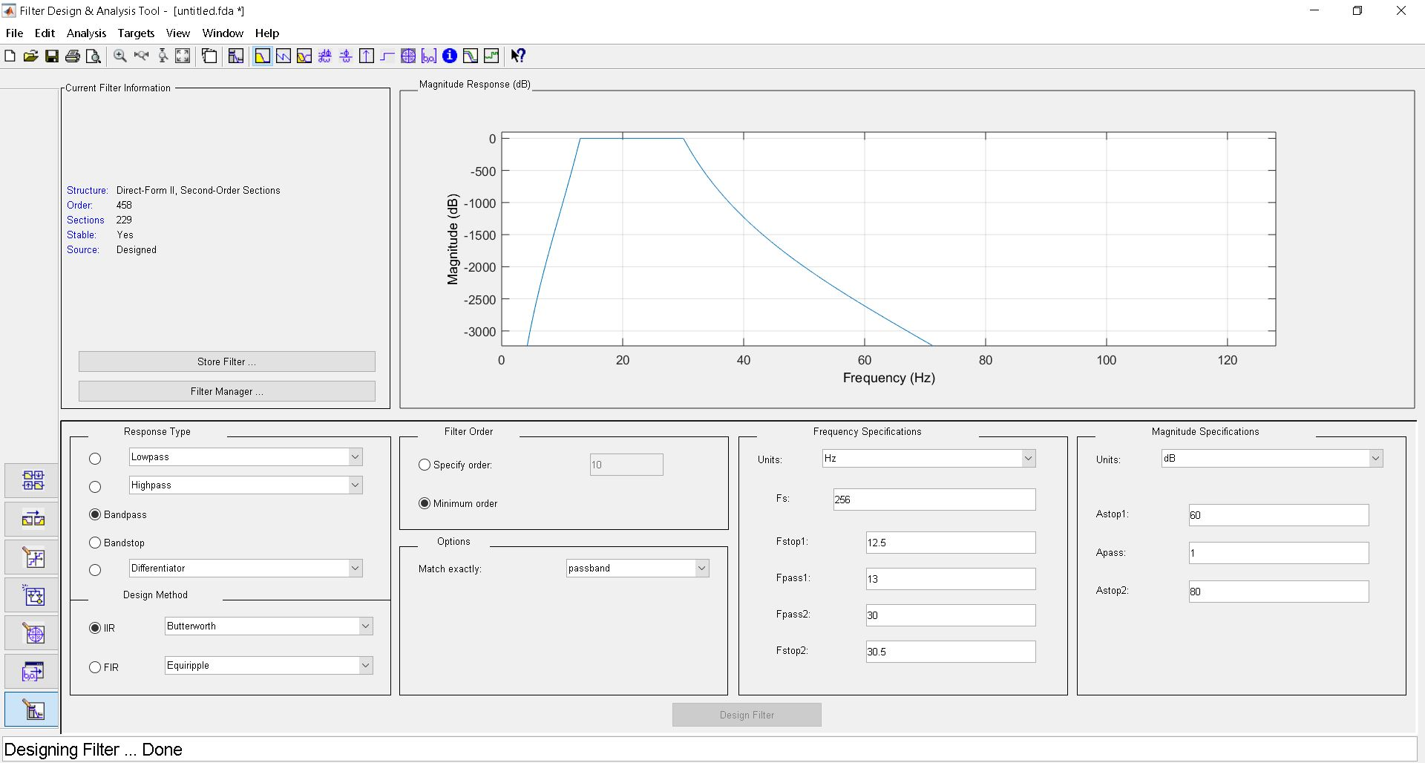

function Hd = delta

%DELTA Returns a discrete-time filter object.

% MATLAB Code

% Generated by MATLAB(R) 9.0 and the Signal Processing Toolbox 7.2.

% Generated on: 12-Mar-2019 20:24:09

% Butterworth Lowpass filter designed using FDESIGN.LOWPASS.

% All frequency values are in Hz.

Fs = 256; % Sampling Frequency

Fpass = 0.5; % Passband Frequency

Fstop = 4; % Stopband Frequency

Apass = 1; % Passband Ripple (dB)

Astop = 80; % Stopband Attenuation (dB)

match = 'passband'; % Band to match exactly

% Construct an FDESIGN object and call its BUTTER method.

h = fdesign.lowpass(Fpass, Fstop, Apass, Astop, Fs);

Hd = design(h, 'butter', 'MatchExactly', match);

% [EOF]

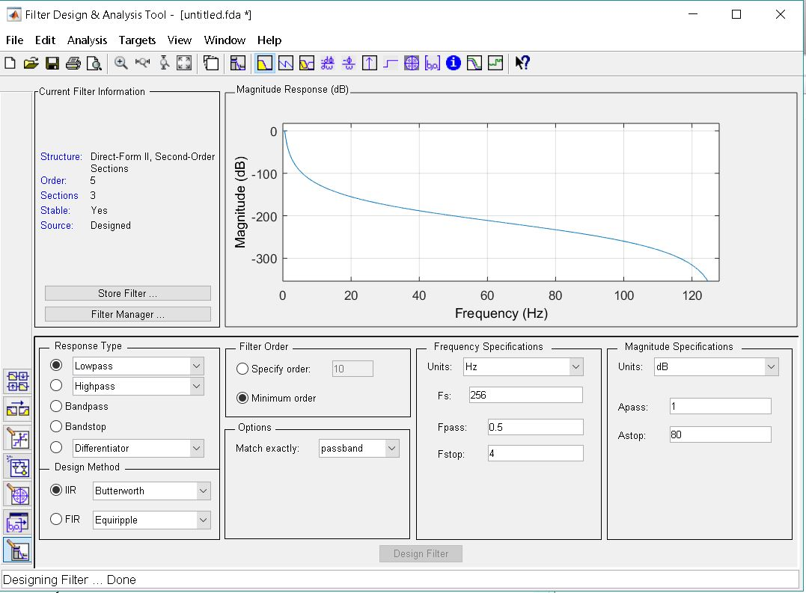

function Hd = theta

%THETA Returns a discrete-time filter object.

% MATLAB Code

% Generated by MATLAB(R) 9.0 and the Signal Processing Toolbox 7.2.

% Generated on: 12-Mar-2019 20:26:05

% Butterworth Bandpass filter designed using FDESIGN.BANDPASS.

% All frequency values are in Hz.

Fs = 256; % Sampling Frequency

Fstop1 = 3.5; % First Stopband Frequency

Fpass1 = 4; % First Passband Frequency

Fpass2 = 7; % Second Passband Frequency

Fstop2 = 7.5; % Second Stopband Frequency

Astop1 = 60; % First Stopband Attenuation (dB)

Apass = 1; % Passband Ripple (dB)

Astop2 = 80; % Second Stopband Attenuation (dB)

match = 'passband'; % Band to match exactly

% Construct an FDESIGN object and call its BUTTER method.

h = fdesign.bandpass(Fstop1, Fpass1, Fpass2, Fstop2, Astop1, Apass, ...

Astop2, Fs);

Hd = design(h, 'butter', 'MatchExactly', match);

% [EOF]

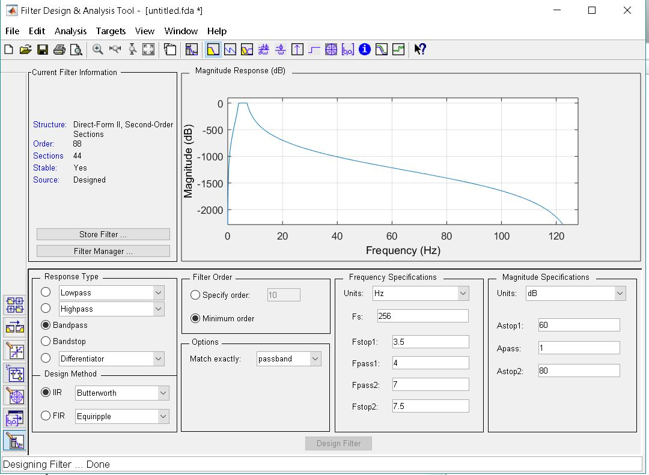

function Hd = gamma

%GAMMA1 Returns a discrete-time filter object.

% MATLAB Code

% Generated by MATLAB(R) 9.0 and the Signal Processing Toolbox 7.2.

% Generated on: 16-Mar-2019 15:08:18

% Butterworth Bandpass filter designed using FDESIGN.BANDPASS.

% All frequency values are in Hz.

Fs = 256; % Sampling Frequency

Fstop1 = 29.5; % First Stopband Frequency

Fpass1 = 30; % First Passband Frequency

Fpass2 = 99.5; % Second Passband Frequency

Fstop2 = 100; % Second Stopband Frequency

Astop1 = 60; % First Stopband Attenuation (dB)

Apass = 1; % Passband Ripple (dB)

Astop2 = 80; % Second Stopband Attenuation (dB)

match = 'passband'; % Band to match exactly

% Construct an FDESIGN object and call its BUTTER method.

h = fdesign.bandpass(Fstop1, Fpass1, Fpass2, Fstop2, Astop1, Apass, ...

Astop2, Fs);

Hd = design(h, 'butter', 'MatchExactly', match);

% [EOF]

